Java Package
A java package is a group of similar types of classes, interfaces and sub-packages.
Package in java can be categorized in two form, built-in package and user-defined package.
There are many built-in packages such as java, lang, awt, javax, swing, net, io, util, sql etc.
Here, we will have the detailed learning of creating and using user-defined packages.

Advantage of Java Package
1) Java package is used to categorize the classes and interfaces so that they can be easily maintained.
2) Java package provides access protection.
3) Java package removes naming collision.

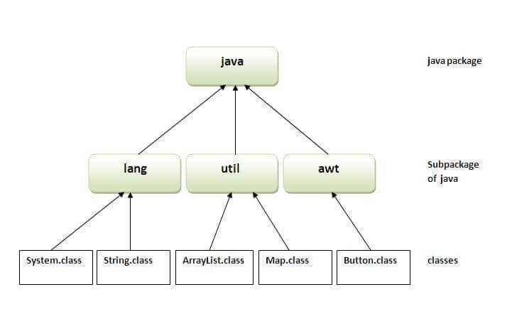

How to access package from another package?
There are three ways to access the package from outside the package.
- import package. *;
- import package.classname;
- fully qualified name.

1) Using packagename.*
If you use package.* then all the classes and interfaces of this package will be accessible.
The import keyword is used to make the classes and interface of another package accessible to the current package.

2) Using packagename.classname
If you import package.classname then only declared class of this package will be accessible.

3) Using fully qualified name
If you use fully qualified name then only declared class of this package will be accessible. Now there is no need to import. But you need to use fully qualified name every time when you are accessing the class or interface.

Note: Sequence of the program must be package then import then class.
